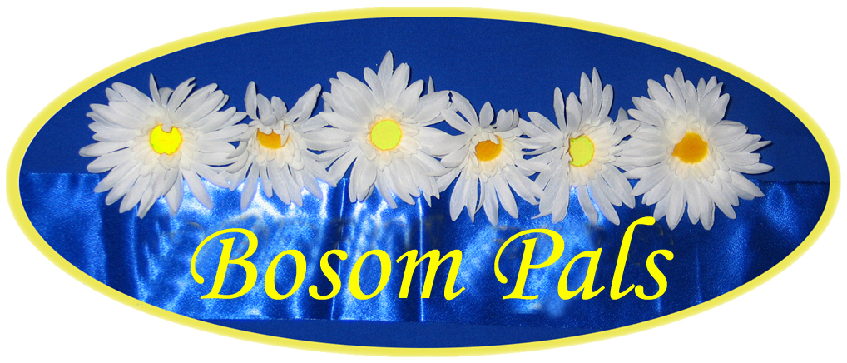

g

CHRISTMAS DINNER 2016

At Bedford Golf Club, Carnoustie Drive,
Great Denham, Bedford MK40 4FF

Friday 3 December at 7 for 7.30 pm

WELCOME DRINK
Mulled wine or orange juice

STARTER
Spiced Parsnip Soup
Served with crème fraiche swirl
Smoked Salmon
Served with horseradish cream and pickled cucumber
Chicken Liver Parfait
Served with red inion reduction

MAINS
Roast turkey
served with all the festive trimmings,
roast root vegetables, brussell sprouts and fondant potato.
Sea Bream Fillet
Served with wilted spinach, crispy bacon and confit potatoes
Roast Beef
Served with roast potatoes, seasonal vegetables and all the festive trimmings
Wild Mushroom Rosotto
Topped with parmesan and rocket

DESSERTS
Christmas pudding served with a Brandy sauce
Snowball profiteroles served with chocolate sauce
Lemon Cheesecake
Served with fresh raspberries and fruit coulis
Fresh Fruit salad

Tea & coffee
Mini iced fruit cake bites

22.95 per person

